**LAB#09**

**ALI MURAD**

**FA17-BECE-0021**

**TASK-1**

m=imread("alimurad.jfif");

m_noise = imnoise(m,"salt & pepper");

imshow(m_noise)

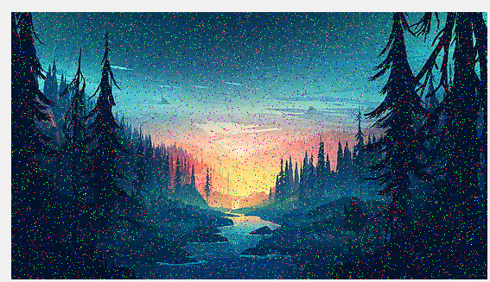

TASK-2

m=imread("alimurad.jfif");

m2=rgb2gray(m);

m_noise = imnoise(m2,'gaussian');

imshow(m_noise);

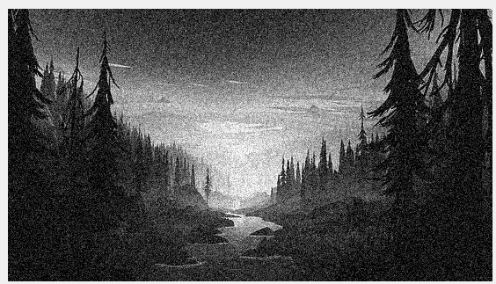

**TASK-3**

m=imread("alimurad.jfif");

m_noise = imnoise(m,'gaussian');

imshow(m_noise);

